Assignment-3

|  |  |
| --- | --- |
| Assignment Date | 20 october2022 |
| Student Name | E Arjun |
| Student Roll Number | 913119104008 |
| Maximum Marks | 2 Marks |

Question-1:

1. **Create a Bucket in IBM object storage.**

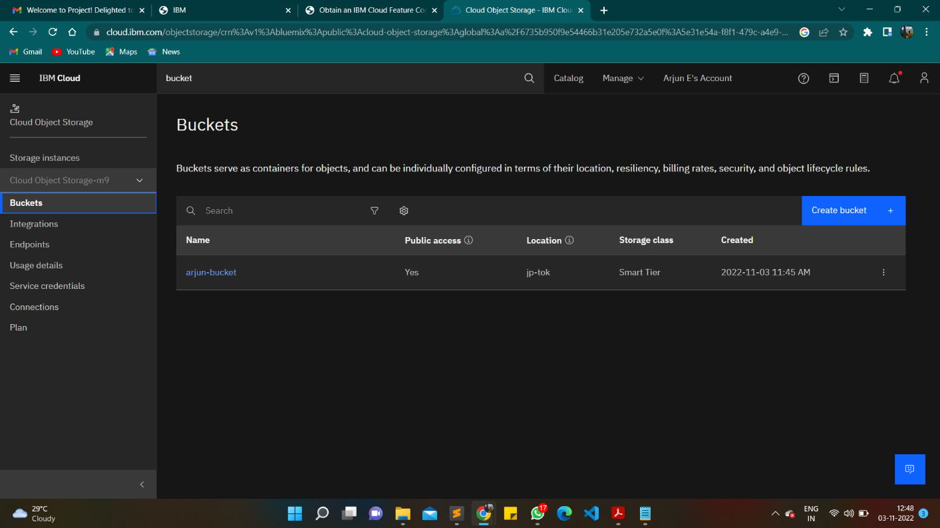

1. **Upload an 5 images to ibm object storage and make it public. write html code to displaying all the 5 images.**

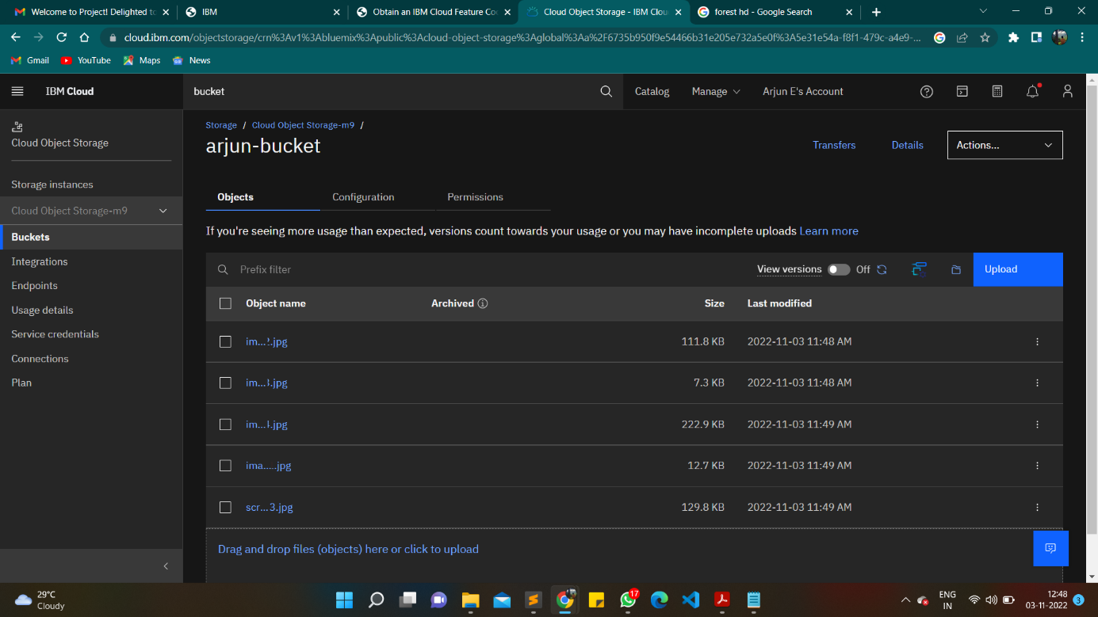

**3.Upload a css page to the object storage and use the same page in your HTML code.**

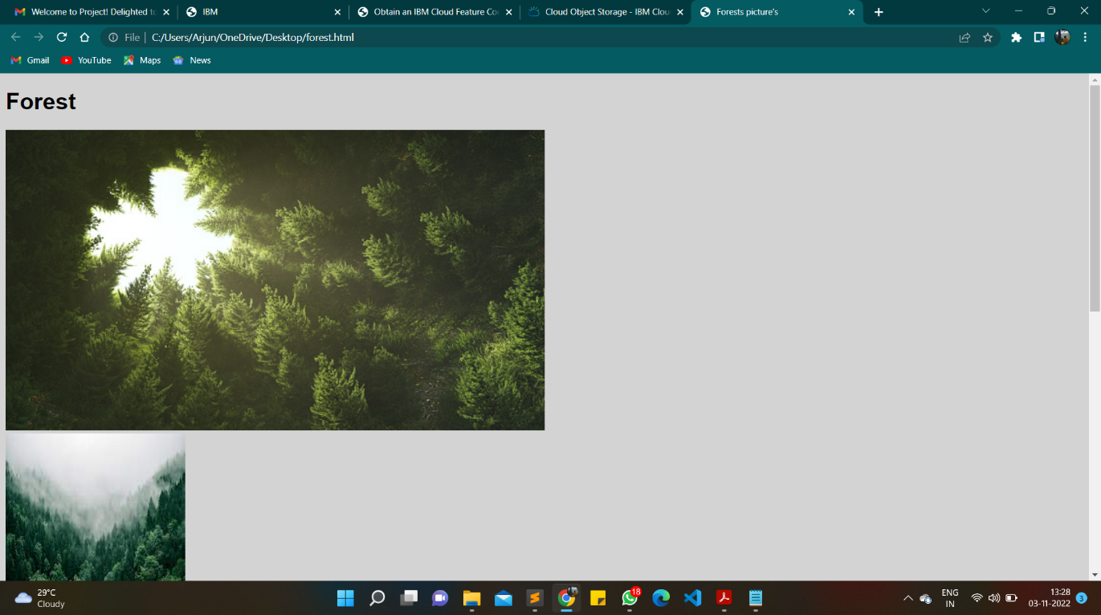

**4.Design a chatbot using IBM Watson assistant for hospital. Ex: User comes with query to knowthebranches for that hospital in your city. Submit the web URL of that chat bot as a assignment.** https://web-chat.global.assistant.watson.appdomain.cloud/preview.html?backgroundImageURL=https%3A%2F%2Fau-syd.assistant.watson.cloud.ibm.com%2Fpublic%2Fimages%2Fupx-91498632-0cd5-4456-82e9-35f1822bc368%3A%3A267e6a16-f19c-4003-b877-7b60e8f29b64&integrationID=d792dcab-62bd-4e49-b274-919b32bf6ce4&region=au-syd&serviceInstanceID=91498632-0cd5-4456-82e9-35f1822bc368



5.Create Watson assistant service with 10 steps and use 3 conditions in it. Load that script in HTMLpage.

